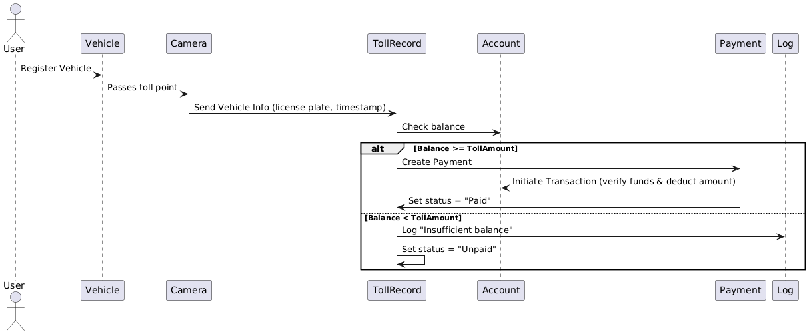

The sequence diagram models an automated electronic toll collection system that detects a vehicle passing a toll camera, checks the owner's account balance, and either processes a payment or logs an unpaid toll if funds are insufficient.

Participants and System Components:
1. User
- Represents the vehicle owner or driver.
- Initiates the process by registering their vehicle with the toll system.
2. Vehicle
- Represents the physical car or transport unit.
- Associated with the User's account.
- Automatically interacts with the system when passing a toll point.
3. Camera
- Installed at the toll point.
- Automatically detects and captures vehicle information (e.g., license plate number and timestamp) as the vehicle passes.
4. TollRecord
- A central service that creates and manages toll transactions.
- Receives vehicle information from the Camera and initiates the process of charging the vehicle’s account.
- Responsible for determining payment status (Paid or Unpaid).
5. Account
- Manages financial data associated with registered users.
- Provides the current balance for a specific vehicle or user.
- Deducts toll amount during the payment transaction.
6. Payment
- Processes monetary transactions.
- Acts as an intermediary between TollRecord and Account to execute a secure deduction.
- Communicates the success or failure of the payment to TollRecord.
7. Log
- Stores events or errors for auditing and system health monitoring.
- Records issues like "Insufficient balance" for future reference or notification.

Step-by-Step Diagram Explanation

Step 1: Vehicle Registration
- User → Vehicle: Register Vehicle
  - The user registers their vehicle in the toll system, linking it to their account.

Step 2: Vehicle Passes Toll Point
- Vehicle → Camera: Passes toll point
  - The vehicle physically passes the toll location.
  - The camera detects this event.
- Camera → TollRecord: Send Vehicle Info (license plate, timestamp)
  - The camera captures the license plate and the exact timestamp of the event.
  - This data is sent to the TollRecord system to begin toll processing.

Step 3: Check Balance
- TollRecord → Account: Check balance
  - The system identifies which account is associated with the vehicle.
  - It queries the current balance to verify whether there are enough funds to deduct the toll amount.

Step 4: Conditional Payment Flow (using alt block)
If Balance is Sufficient (Balance ≥ TollAmount)
- TollRecord → Payment: Create Payment
  - TollRecord requests a payment to be created for the toll amount.
- Payment → Account: Initiate Transaction (verify funds & deduct amount)
  - Payment system ensures funds are still available.
  - Deducts the toll amount from the user’s account.
- Payment → TollRecord: Set status = "Paid"
  - Payment confirms the transaction was successful.
  - TollRecord updates the transaction status as "Paid".

If Balance is Insufficient (Balance < TollAmount)
- TollRecord → Log: Log "Insufficient balance"
  - The system logs this issue for further review, alerting support or triggering user notifications.
- TollRecord → TollRecord: Set status = "Unpaid"
  - The TollRecord marks the transaction as “Unpaid”.
  - This could later trigger follow-up processes like reminders or penalties.

